HOMEWORK ASSIGNMENT
Week 3
30 Points Maximum

Name ______________________________________
NETW204
Homework #3
Due Date _____________________________________

Professor ______________________________________

Inter-VLAN Routing

- A Given the network diagram below. Enter the commands, including the router prompt, to configure the router, for router-on-a-stick. (10 points)
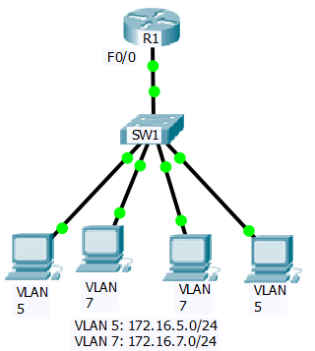
- Given the network diagram below. Enter the commands, including the switch prompt, to configure S1 to forward VLAN traffic. (10 points)
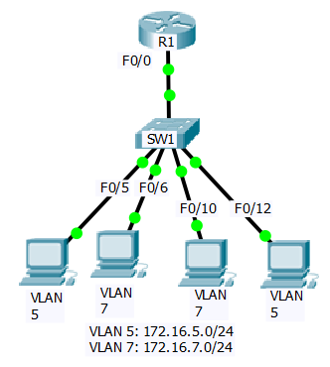

- The organization added a new VLAN, VLAN 200, to the network. You are required to implement a solution that provides the best performance to the server segment, VLAN 200. How would you configure the router to ensure that the server segment will not experience bottleneck between the end devices on the server segment and the router? Enter the commands you would use on the router to implement this solution. Justify your answer. (10 points)
